**QR-BASED RECYCLING REWARD PLATFORM FOR WASTE COLLECTION**

**BY**

**AMAEFULE MERCY CHIMNONSO**

**2019/SC/CSC/0077**

**SUBMITTED TO THE DEPARTMENT OF COMPUTER SCIENCE, FACULTY OF COMPUTING, FEDERAL UNIVERSITY OF LAFIA, NASARAWA STATE.**

**IN PARTIAL FULFILLMENT OF THE REQUIREMENTS FOR THE AWARD OF A BACHELOR OF SCIENCE (B.Sc.) IN COMPUTER SCIENCE**

**SEPTEMBER 2024**

# DECLARATION

I Amaefule Mercy Chimnonso, hereby declare that this research project titled “Qr-based recycling reward platform for waste collection” has been carried out by me under the supervision of Engr. Dr. M.M Liman. It has not been presented for the award of any degree in any institution. All sources of information are specifically acknowledged by means of references.

|  |  |  |  |
| --- | --- | --- | --- |
| ___________________  Signature |  |  | ___________________  Date |

# CERTIFICATION

This project report entitled “**Qr-based recycling reward platform for waste collection**” meet the regulations governing the award of Bachelor of Science of Federal University of Lafia and is approved for its contribution to knowledge and literary presentation.

____________________________ ________________  
Engr. Dr. M.M Liman   
**Project Supervisor Date**

____________________________ ________________  
Assoc. Prof Timothy Moses   
**Head of Department Date**

____________________________ ________________  
Dr. Agushaka J. Ovre   
**Dean Faculty of Computing Date**

____________________________ ________________  
Prof. Philip O.Achimugu   
**External Examiner Date**

# DEDICATION

# This project is dedicated to God Almighty.

I co-dedicate this work to my Mentor Mr. Nicholas Aminaho Efewengbe and to my family members, Mr.& Mrs Amaefule, Victory, Praise and Isaac.

# ACKNOWLEDGEMENT

First and foremost, I am deeply grateful to God Almighty whom in His Infinite mercy enabled me to complete this project successfully.

Firstly, I would like to acknowledge the great assistance of the Head of Department Computer science, Prof. Timothy Moses for his guidance and training, My able lecturer Mr.A. Habila ,my Level adviser Mr. B.A Bamanga and my project supervisor Dr. M.M. Liman for their continuous support, instructions and trainings, it helped shaped this project to what it is, and to the entire class of 2023 Computer science, I appreciate you all.

Without Mentors they say, makes the road tougher, so I would like to appreciate the Mentors I was privilege to be under their tutelage, Mr. Asher Jocos, Mr. Tasiu Kwaplong, Mr. Raphael Eze Mr. Michael Mathias and Mr. Anthony Ameh, together their words of inspiration and guidance made the completion of this project a success.

I would also like to acknowledge the support and encouragement from my good friends, Alheri Ayuba, Esther Anzaku, Favour Ayuba, Damilola Oloruntobi,Goodness Oviohen and the entire team of Big 11 especially Margaret Elom, your unending hospitality and kind gestures throughout the period of writing this project was top-notch.  
To Ugochukwu Ozor, I appreciate the efforts, it went a long way.

Lastly, I would like to express my deepest gratitude to my family for their unwavering love, understanding, and support especially my younger brother (Isaac Amaefule).

# TABLE OF CONTENTS

DECLARATION i

CERTIFICATION ii

DEDICATION iii

ACKNOWLEDGEMENT iv

TABLE OF CONTENTS v

LIST OF FIGURES viii

LIST OF TABLES ix

ABSTRACT x

CHAPTER ONE: INTRODUCTION 1

1.1 Background of study 1

1.2 Statement of the Problem 3

1.3 Aim and Objectives 4

1.3 Significance of the Study 4

1.4 Scope of the Study 5

1.6 Organization of the Work 5

1.7 Definition of Terms 6

CHAPTER TWO: LITERATURE REVIEW 7

2.1 Theoretical Framework 7

2.1.1 Automated Systems for Recycling 8

2.1.2 QR Code Technology in Recycling Systems 10

2.1.3 User Engagement and Environmental Education 12

2.1.4 Real-Time Tracking in Recycling Systems 13

2.1.5 Digital Transformation in Waste Management 14

2.2 Review of related Works 16

2.3 Summary of Reviewed Work s and Research Gaps 20

2.3.1 Summary of Literature Reviewed 21

CHAPTER THREE: SYSTEM ANALSIS, DESIGN AND METHODOLOGY 23

3.1 Analysis of the Existing System 23

3.1.1 Data Flow of the Existing System 24

3.1.2 Advantages of the Existing System 25

3.1.3 Disadvantages of the Existing System 25

3.2 Analysis of the New System 26

3.2.1 Justification of the New System 27

3.3 Methodology Adopted 28

3.4 High Model of the New System 29

3.5 Specifications 31

3.5.1 Program Module Specification 31

3.5.2 Database Development Tool 34

3.5.3 Database Design and Structure 34

3.5.4 Input/Output Design 35

3.5.5 Data Dictionary 36

3.6 System Flowchart 39

CHAPTER FOUR: SYSTEM IMPLEMENTATION, TESTING, RESULTS AND DOCUMENTATION 40

4.1 System Implementation 40

4.1.1 New System Requirements 40

4.1.2 Program Development 42

4.2 Testing and Results 44

4.2.1 System Testing 44

4.3 Results and Documentation 48

4.3.1 Web Application for Manufacturers 48

4.3.2 Mobile Application for Collectors 51

4.3.3 All user’s interface 53

4.3.3 Error Handling 55

CHAPTER FIVE: SUMMARY, CONCLUSION AND RECOMMENDATION 56

5.1 Summary 56

5.2 Conclusion 57

5.3 Recommendation 59

5.3.1 Application Areas 60

5.3.2 Suggestions for Further Research 61

REFERENCES 63

APPENDIX: SOURCE CODE 65

**LIST OF FIGURES**

Figure 3.1: Data flow diagram of existing system 24

Figure 3.2: System Methodology for the developed system 29

Figure 3.3: Architectural Diagram for the developed system 30

Figure 3.4:Entity Releatinship Diagram fo the developed system 35

Figure 3.5: System Flowcart 39

Figure 4.0 HomePage 48

Figure 4.1: Manufacturer's Dashboard 49

Figure 4.2: Manufacturer's Add product 50

Figure 4.3: Manufacturer's Product managemenat 50

Figure 4.4: QR cod egeneratoin 50

Figure 4.5: IPayment Threshold 51

Figure 4.6: Collector's Points....................................................................................................51

Figure 4.7: Collector's Scanning interface5.............................................................................52

Figure 4.8 Contributo's points 52

Figure 4.9.1: Registsration Page 53

Figure 4.9.2: Login Page 53

Figure 4.9.3:Query for contributos Points 54

Figure 4.10: Error Handling 55

# LIST OF TABLES

Table 2.1: Summary of Literarture Reviewed 21

Table 3.1: Points Model data Dictionary 36

Table 3.2: Produc tModel data Dictionary 36

Table 3.3: Submission Model data Dictionary 37

Table 3.4: User Model data Dictionary 37

# ABSTRACT

The increasing challenge of managing recyclable waste and promoting environmentally friendly practices has become a critical concern today. Traditional recycling systems often lack engagement, transparency, and an incentive structure to motivate users, resulting in lower participation rates and inefficiencies in recycling operations. The aim of this project is to develop Ecopint, a web-based recycling platform that encourages the recovery of recyclable products like plastics, glass, and paper from users by offering a structured incentive system.

Ecopint leverages modern technology, such as QR code tracking and a points-based reward system, to create a seamless and user-friendly experience for manufacturers, collectors, and contributors. By implementing a dual-interface system—a web app for manufacturers to register products and a mobile app for collectors to scan QR codes and allocate points—Ecopint fosters collaboration across the recycling chain. The project employs a combination of Node.js for the backend, frontend technologies for the interfaces, and MongoDB for dynamic data management, ensuring a robust and scalable system.

Through rigorous testing and evaluation, Ecopint has demonstrated its ability to streamline the recycling process, offering real-time point allocation and transparent tracking of user contributions. The system effectively motivates users to participate in recycling by providing monetary rewards and encouraging community involvement. However, while Ecopint addresses several gaps in traditional recycling methods, opportunities for future enhancements include integrating IoT-enabled automation for waste submission , and scaling the system to reach a broader audience.

Finally, Ecopint represents an innovative solution to the problem of low recycling participation and inefficiency. By combining technology with a user-centered incentive model, the system promotes sustainability and encourages active participation in recycling, ultimately contributing to a more circular economy and a healthier environment.

# 

# CHAPTER ONE: INTRODUCTION

## Background of study

The global increase in waste production, particularly in urban areas, has amplified the need for efficient waste management and recycling systems. As urban populations grow and consumption patterns increase, industries and individuals generate massive amounts of waste, including plastic, paper, and metals, which are often discarded improperly. This mismanagement of waste leads to environmental degradation, such as the accumulation of non-biodegradable materials in landfills and oceans, contributing to pollution and the depletion of natural resources. Effective waste management systems are therefore crucial to mitigating these negative impacts and promoting sustainability.

Recycling, as a subset of waste management, plays a pivotal role in conserving resources, reducing energy consumption, and minimizing environmental pollution. According to Hughes (2022), recycling helps reduce greenhouse gas emissions, conserves natural resources, and decreases reliance on landfills, all of which contribute to mitigating climate change. Recycling paper alone saves 17 trees for every ton of paper recycled and reduces water and energy consumption by up to 70% compared to producing new paper from raw materials (Hughes, 2022). These environmental benefits extend to other recyclable materials, such as plastics and metals, making recycling a key component in global sustainability efforts.

Technological advancements have further enhanced the efficiency of recycling processes. As noted by Cabalova et al. (2011), the introduction of advanced recycling technologies has significantly reduced environmental pollution associated with waste. Recycling paper, for instance, not only conserves energy and reduces waste in landfills but also decreases the need for harmful chemicals used in the paper production process. The use of recycled fibers in manufacturing has been shown to reduce air and water pollution by as much as 74%, highlighting the critical role of recycling in environmental conservation (Cabalova et al., 2011).

However, despite the environmental benefits of recycling, many industries and individuals still face challenges in effectively managing waste. A major issue is the lack of streamlined systems for tracking and managing recyclable products, which often leads to low participation in recycling programs. To address this challenge, technological solutions are being developed to engage the public and facilitate more efficient recycling processes. One such innovation is the use of QR-based systems to track and manage recyclable products. QR codes allow for transparent and real-time tracking of recyclable items, making it easier to monitor and manage the recycling process from product creation to collection.

This project focuses on the development of a web-based application designed to facilitate the collection of recyclable waste products, with an emphasis on plastic and paper waste. The system incorporates QR codes to enhance the recycling process by enabling manufacturers to register their products, assign recyclability points, and generate unique QR codes for each product. These QR codes are scanned by collectors and contributors, providing a transparent and efficient method of tracking recyclable products from submission to collection. The system not only simplifies the recycling workflow but also incentivizes contributors by awarding points for each submission, which can be converted into monetary rewards once a threshold is reached.

The software aims to create a comprehensive ecosystem where manufacturers, contributors, and collectors collaborate to improve recycling practices. Manufacturers generate QR codes for their products to enhance traceability, contributors submit recyclable items and earn points, and collectors use mobile QR scanning to track and verify submissions. This process not only simplifies the recycling workflow but also promotes greater engagement in recycling efforts, contributing to the broader goal of environmental sustainability.

By leveraging technology, this system addresses several challenges identified in traditional recycling systems, including inefficient tracking, low participation rates, and a lack of incentives. As the research by Hughes (2022) and Cabalova et al. (2011) suggests, improving the efficiency and traceability of recycling processes through technology can have far-reaching environmental benefits. This project, therefore, contributes to the growing body of work on waste management by introducing a scalable and incentivized solution that encourages active participation in recycling and fosters collaboration among key stakeholders.

## Statement of the Problem

Despite the increasing global awareness of the importance of recycling, many challenges remain in implementing effective recycling systems. Current recycling processes often suffer from inefficiencies, lack of tracking, and minimal incentives for contributors. The absence of a streamlined method for managing recyclable waste, especially in developing regions, has resulted in low participation rates and poor environmental outcomes.

Some key problems include:

1. **Lack of Tracking and Accountability**: Without a proper system for tracking recyclable materials, contributors are often unaware of the impact of their contributions. This leads to lower participation and an inability to quantify recycling efforts.
2. **Inefficient Reward Systems**: Many recycling systems lack an effective method of giving incentives to users. Contributors often lack motivation to engage actively in recycling due to the absence of clear rewards.
3. **Disconnected Stakeholders**: Manufacturers, collectors, and contributors frequently operate in silos, making it difficult to coordinate recycling efforts efficiently.
4. **Manual Processes**: Traditional recycling processes are often manually driven, leading to inefficiencies in data management, tracking, and submission verification

To address these challenges, this project proposes the development of a web-based application that incorporates QR codes to improve transparency, and efficiency in the recycling process.

## 1.3 Aim and Objectives

**Aim**

The aim of this project is to develop a QR-based web application that enhances the recycling process by enabling manufacturers to register products with QR codes, contributors to submit recyclable items, and collectors to track submissions using mobile QR scanning. The system will reward contributors and collectors for their participation, thus encouraging greater engagement in recycling efforts.

**Objectives**

1. To implement a web application that allows manufacturers to register recyclable products, assign points, and generate QR codes for tracking submissions.
2. To build a mobile interface for collectors to scan QR codes and track recyclable items, while providing real-time submission tracking for manufacturers and contributors.
3. To establish a points-based reward system for contributors and collectors, enabling them to accumulate and convert points to monetary rewards, while promoting collaboration among all stakeholders.

## Significance of the Study

This project addresses the critical need for innovative, technology-driven recycling solutions. By leveraging QR codes, the system enhances the efficiency of recycling processes and fosters active participation in waste management. This project offers significant benefits to both users and society by introducing an innovative, technology-driven recycling solution. The use of QR codes enhances the efficiency of recycling processes, making it easier for users to track and submit recyclable items. By integrating a points-based reward system, the platform incentivizes users to participate actively in recycling, leading to higher recycling rates and engagement.

From a societal perspective, the project contributes to reducing landfill waste, conserving natural resources, and mitigating environmental pollution. The integration of modern technology such as QR codes and mobile scanning showcases how digital innovation can address real-world environmental challenges, promoting a culture of sustainability and environmental responsibility in the community.

## Scope of the Study

The scope of this project encompasses the development and deployment of a QR-based recycling management system. The focus is on three primary user groups: manufacturers, contributors, and collectors. The system will allow manufacturers to register products, generate QR codes, and assign points based on the recyclability of their products. Contributors will be able to submit recyclable items by scanning QR codes, while collectors will track and verify submissions via mobile devices.

Key features include:

* QR code generation for each product registered by manufacturers.
* Real-time tracking of submissions by contributors and collectors.
* A points-based reward system for contributors, with the ability to convert points into cash.
* Mobile-friendly interface for collectors to scan and track QR codes using device cameras.

## 1.6 Organization of the Work

This project is organized into five chapters, each focusing on distinct aspects of the study. Chapter One introduces the project by presenting the background, problem statement, aim, objectives, significance, and scope of the study. Chapter Two reviews related literature on recycling technologies, QR-based systems, and incentivized waste management solutions. Chapter Three covers the system design and methodology, detailing the development process, database structures, and system architecture. Chapter Four focuses on the implementation and testing of the system, highlighting challenges, solutions, and results. Finally, Chapter Five concludes the project with a summary of findings and recommendations for future improvements.

## 1.7 Definition of Terms

* **QR Code**: A machine-readable code used to store information about products, enabling tracking and management of recycling activities.
* **Contributor**: A user who submits recyclable products through the system and earns points based on their contributions.
* **Collector**: A user responsible for collecting recyclable items and verifying submissions by scanning QR codes using a mobile device usually a store where the products are sold.
* **Manufacturer**: A company or individual who registers recyclable products on the system and generates QR codes for tracking purposes.
* **Points-Based Reward System**: A system that awards points to contributors for submitting recyclable products, which is converted into monetary rewards.
* **Submission Tracking**: The process of monitoring recyclable products after submission
* **QR Scanning**: The use of mobile device cameras to scan QR codes and track submissions.

# 

# CHAPTER TWO: LITERATURE REVIEW

2.1 Theoretical Framework

The rise of web-based applications has opened new avenues for promoting environmental sustainability practices, particularly in waste management and recycling systems. These technological advancements provide innovative solutions that not only motivate participation but also enable precise tracking of recycling activities, fostering greater accountability and engagement from users.

In the context of this QR-based system, technology is seamlessly integrated to bridge the gap between recycling behavior and effective waste management. By using features such as real-time tracking and QR code scanning, this system enables participants to efficiently submit recyclable products, while also providing transparency throughout the recycling process. The use of QR codes for tracking product submissions adds transparency, allowing users to monitor their contributions and giving collectors the ability to efficiently record and verify submissions.

Within educational settings, where the software is primarily targeted, factors such as environmental concern, attitudes towards recycling, and the presence of institutional support play critical roles in shaping recycling behaviors. According to Sallaku et al. (2019), universities and schools have a unique opportunity to increase environmental awareness among students and staff, making them ideal environments for implementing recycling initiatives. By leveraging this platform, institutions can create an eco-friendly culture by enabling students and staff to submit recyclable products, thus fostering a sense of responsibility for the environment.

While the system offers practical solutions for streamlining the recycling process, there are still opportunities for refining the approach to ensure the best outcomes. Ourdas and Ponis (2023) argue that a structured approach to understanding the behavior of users within sustainability systems is crucial. For this QR-based system, incorporating real-time feedback can enhance user engagement by providing instant confirmation of successful submissions. This encourages users to recycle more frequently by offering a simplified process of tracking their contributions and ensuring that their efforts are recorded accurately.

Beyond simplifying the recycling process, the platform can also serve as an educational tool by raising awareness of sustainability issues. According to Sá Escudeiro and Gouveia Campos (2023), systems that combine real-world applications are particularly effective at driving behavioral change. In this context, the QR-based recycling system is designed to educate users on the importance of recycling through hands-on participation, while offering transparency in how their efforts contribute to environmental sustainability. This not only reinforces proper recycling habits but also instills long-term ecological responsibility among the participants, especially in younger generations.

By integrating web-based technologies and QR code tracking, this QR-based recycling platform provides a scalable and efficient solution to enhance recycling behaviors in educational institutions and beyond. The combination of digital innovation, real-time tracking, and transparent reporting fosters a culture of environmental stewardship, creating a sustainable impact on waste management practices.

### 2.1.1 Automated Systems for Recycling

Automated systems for recycling have emerged as a promising solution to address the challenges of waste management in smart cities and improve the efficiency of recycling processes. These systems leverage advanced technologies such as artificial intelligence, machine learning, and computer vision to enhance the sorting and classification of recyclable materials.

One approach to automated recycling involves the use of digital models that can automatically sort and classify waste according to recycling requirements. By combining image processing techniques with artificial neural networks (ANN) and feature fusion, these systems can achieve high accuracy in waste classification. For instance, a model utilizing various extracted features and machine learning algorithms has demonstrated an accuracy of 91.7% in sorting waste across three categories. This digital-enabled approach has the potential to significantly improve waste sorting services and recycling decisions throughout the value chain in smart cities (Mohammed et al., 2023).

Another significant advancement in automated recycling systems is the integration of robotics with sophisticated visual and manipulation capabilities. These robotic systems are designed to operate in the heterogeneous, complex, and unpredictable environment of waste sorting facilities. By incorporating deep learning technologies and computer vision modules, these robots can identify and sort items with high precision. The development of low-cost computer vision modules based on deep learning has made it possible to create effective autonomous robotic systems for categorizing and physically sorting recyclables according to material types (Koskinopoulou et al., 2021).

The implementation of such robotic systems in waste processing plants has shown promising results, even under difficult and demanding industrial conditions. These systems not only improve the processing of recyclables but also offer the potential to increase the overall efficiency and effectiveness of recycling operations. The availability of open-source datasets and image processing scripts for object identification, masking, and synthetic placement against multiple backgrounds further facilitates research and development in this field (Koskinopoulou et al., 2021).

In addition to advancements in sorting and classification, automation plays a crucial role in calculating points and rewarding participants in recycling initiatives. When the weight of paper is recorded using digital scales, the system can automatically calculate and assign points to the respective schools. This immediate calculation and allocation of points streamline the reward process, ensuring accuracy and enhancing user engagement. The integration of automation for point calculation contributes to the seamless operation of the recycling initiative, encouraging more schools to participate actively.

The integration of these automated systems into the recycling process represents a significant step towards realizing the circular economy vision for smart cities. By improving the accuracy and efficiency of waste sorting and classification, and automating the point calculation and reward process, these technologies can help overcome practical difficulties in recycling and accelerate progress towards sustainable waste management practices.

### 2.1.2 QR Code Technology in Recycling Systems

QR (Quick Response) code technology has become an incredibly useful tool for making processes more efficient and transparent, and recycling systems are no exception. Originally developed to manage inventory in the manufacturing industry, QR codes have found their way into many different sectors because they can hold a lot of information, are easy to scan, and can be accessed by anyone with a smartphone (Yuan et al., 2016). When applied to recycling, QR codes help streamline the process of tracking recyclable products, making the overall waste management system more organized and effective.

One of the key advantages of QR codes in recycling is that they provide real-time tracking and monitoring of the materials being recycled. By embedding information like the type of material, its recyclability, and the manufacturer’s details in a QR code, recycling submissions can be logged quickly and accurately. This ensures transparency and reduces errors in data collection, which can often occur in manual systems. As a result, using QR codes makes waste management more scalable and easier to handle (Tan et al., 2018).

Another important benefit is how QR codes engage users in the recycling process. Contributors can scan QR codes on recyclable products with their smartphones, instantly accessing details about the product’s recycling status. This ease of use not only encourages more participation in recycling but also raises awareness about the environmental impact of waste (Kim & Shin, 2017). Because QR code technology is so accessible, it works well in both urban and rural areas, requiring only basic digital tools to get started.

QR codes also make collaboration between different groups—such as manufacturers, collectors, and recycling companies much smoother. Manufacturers can generate QR codes for their products during production, allowing collectors and recycling companies to easily track the items from when they are submitted to when they are recycled. This system makes sure everyone involved has access to accurate, up-to-date information, improving coordination and efficiency along the way (Bollweg et al., 2020).

QR codes are aligned with the global push toward digitalization and data-driven solutions for sustainability. As Bollweg et al. (2020) pointed out, integrating digital tools like QR codes into recycling systems helps with better data management, which is crucial for optimizing waste collection, lowering costs, and improving recycling rates. By making recycling processes digital, organizations can gather valuable data to analyze trends and make informed decisions about how best to manage waste.

QR codes bring many benefits to recycling systems. They make tracking products easier, improve efficiency, increase user engagement, and help different groups work together better. By embedding important information in a simple QR code, we can make recycling more transparent and accountable. As recycling practices continue to evolve, QR codes will likely play an even bigger role in promoting sustainability and improving how we manage waste.

### 2.1.3 User Engagement and Environmental Education

Environmental education plays a crucial role in addressing climate change and promoting sustainable lifestyles. It not only increases knowledge but also encourages changes in attitudes and behaviors. To enhance the effectiveness of environmental education, innovative approaches such as gamification have gained attention, particularly for engaging youth in pro-environmental behaviors.

Gamification platforms designed for environmental education can significantly impact pro-environmental behavioral change. Key elements that increase the success of these platforms include meaning, ownership, social influence, achievability, challenge, and credibility. The more attributes enclosed in the gamification design, the stronger physical and mental connections it builds with participants. This insight can guide educators in selecting best practices and help gamification designer’s better influence behavioral change through game mechanics (Ouariachi et al., 2020). However, the traditional knowledge-attitudes-behavior pathway that underpins much of environmental education practice has been challenged. Recent research suggests that certain types of knowledge are more likely to influence behaviors than others, and working with existing attitudes is generally more effective than attempting to change them. Environmental education programs can benefit from expanding their focus beyond knowledge and attitudes to include outcomes such as nature connectedness, sense of place, efficacy, identity, norms, social capital, youth assets, and individual wellbeing (Krasny, 2020). To enhance the effectiveness of environmental education programs, educators can construct theories of change that target specific intermediate outcomes likely to lead to environmental behaviors and collective action. By planning activities to achieve these intermediate outcomes, programs can more effectively foster long-term environmental actions. In some cases, directly engaging participants in desired behaviors or collective actions can lead to changes in efficacy, sense of place, and other intermediate outcomes, which in turn promote future environmental actions (Krasny, 2020).

Evaluation is crucial for assessing the impact of environmental education programs. Both quantitative and qualitative methods can be employed to measure changes in environmental behaviors and intermediate outcomes. Surveys and qualitative evaluation guidelines can help educators assess the effectiveness of their programs and make data-driven improvements (Krasny, 2020).

By incorporating these insights into environmental education initiatives, educators and program designers can create more engaging, effective, and impactful experiences that foster long-term pro-environmental behaviors and contribute to broader sustainability goals.

### 2.1.4 Real-Time Tracking in Recycling Systems

Real-time tracking is an essential feature in modern recycling systems, providing transparency and accountability throughout the recycling process. By incorporating real-time tracking, organizations and individuals can follow recyclable products as they move from the point of submission to collection and final processing. This enhances the efficiency of waste management operations and ensures that recyclable materials are properly processed, reducing the likelihood of mismanagement or loss.

QR code technology plays a crucial role in enabling real-time tracking in recycling systems. By scanning QR codes assigned to products, collectors and recycling companies can instantly access data regarding the product’s recyclability, origin, and status in the recycling cycle. This ensures that all stakeholders, from contributors to recyclers, have up-to-date information on the materials they are managing (Tan et al., 2018). This real-time flow of data helps eliminate delays, improves operational efficiency, and supports decision-making processes in recycling systems.

The benefits of real-time tracking extend beyond operational efficiency. For contributors, real-time updates provide reassurance that their recyclable materials are being processed properly. By receiving instant confirmation through QR code scans, users are more likely to engage in recycling activities, knowing that their efforts are being tracked and contributing to environmental sustainability. Additionally, real-time tracking offers recycling companies valuable insights into collection patterns, helping them optimize routes and resource allocation (Zhang et al., 2020). This data-driven approach not only reduces operational costs but also helps maximize the impact of recycling programs.

Moreso, real-time tracking helps address issues related to contamination in recycling. By instantly identifying and isolating contaminated products or incorrect submissions, recycling facilities can ensure that only proper materials enter the recycling stream. This reduces the risk of contamination and improves the overall quality of recycled materials, contributing to more effective waste management practices (Geyer et al., 2017).

In conclusion, real-time tracking, facilitated by QR codes and digital platforms, is transforming the efficiency and transparency of recycling systems. This technology ensures accurate, up-to-date information on recyclable materials, optimizing operations and encouraging greater participation in recycling efforts.

### 2.1.5 Digital Transformation in Waste Management

The introduction of digital technologies has dramatically changed how waste is handled, collected, and processed. In the past, managing waste relied on manual processes that were often inefficient and difficult to scale. However, the rise of digital tools like QR codes, mobile apps, IoT (Internet of Things) devices, and data analytics has transformed waste management into a much more streamlined and efficient system. This shift has allowed organizations to better track waste, improve how it’s managed, and take steps toward more sustainable waste disposal practices.

QR codes, for example, have made waste tracking more organized and transparent. By assigning QR codes to recyclable materials, manufacturers and recycling companies can easily monitor the journey of these materials from the point of production to when they are collected and processed. This allows for better data collection, which in turn improves decision-making and resource allocation. As noted by Bollweg et al. (2020), digitalization of waste management helps companies optimize collection routes, reduce costs, and boost recycling rates.

IoT technology—such as smart sensors—has made waste monitoring even more efficient. For instance, sensors can detect when waste bins are full and notify collection companies. This eliminates unnecessary trips and reduces fuel consumption, which helps lower greenhouse gas emissions and contributes to environmental sustainability (Kalantarifard & Yang, 2012).

Moreover, digital platforms, including mobile apps, have made it easier for individuals to engage with recycling efforts. With the help of QR codes, users can now track their recycling activities, see their contributions in real-time, and become more active in reducing waste. This personalized experience encourages people to recycle more and adopt sustainable behaviors.

The digital transformation in waste management—led by tools like QR codes, IoT, and mobile technologies—has made waste management more efficient, transparent, and sustainable. As technology continues to advance, the waste management industry is poised to become even more effective in reducing environmental impact.

## 2.2 Review of related Works

The study of automated and reward-based paper recycling initiatives is supported by various studies that delve into the application of gamification, the use of advanced technologies, and the development of pro-environmental behaviors. These studies collectively highlight the potential of integrating innovative approaches to enhance recycling rates and foster environmentally friendly habits especially in higher institutions. Technological advancements offer innovative solutions that motivate participation and enable precise tracking of submission progress. Recent research has demonstrated the potential of these approaches in enhancing recycling behaviors and environmental awareness.

Zhang et al. (2020) address the challenge of household waste recycling in cities by designing a smart incentive-based recycling system using Internet of Things (IoT) and data analysis technologies. Their system comprises four key components: amount pattern discovery, price adjustment suggestion, waste-collection amount forecasting, and information sharing among stakeholders. The researchers implemented their system in a pilot community in Shanghai, analyzing data on 19 specific recyclable items over a seven-month period.

The results showed a significant increase (229.3%) in the recyclable waste-collection amount. However, the weekly pattern of collection became imbalanced, particularly on weekends. The analysis suggested that the adjusting of pricing for specific items to better balance collection amounts and allocate resources more efficiently. Their two-month trend analysis and fortnight forecasting capabilities aim to help recycling businesses plan more rationally. The new information-sharing platform facilitated smoother collaboration among stakeholders in household waste recycling and reduction efforts.

Gibovic and Bikfalvi (2021) conducted a pilot project in Catalonia, Spain, to encourage plastic recycling among families using a virtual reward token called RECICLOS. The study introduced gamification elements through raffles and lotteries, along with a webapp prototype for registering recycled plastic. Over a six-week period, 1,053 families (10% of the target population) registered for the scheme.

The researchers emphasize the multidimensional aspects of recycling activities and their strong connection to human behavioral patterns. They argue that mobile technologies have significant potential in this field due to the high demand for communication and interaction. The results suggest that varied, effective, and innovative incentive schemes can influence people's recycling habits positively.

Urquijo (2018) developed a system, WasteApp, an application developed as part of the European URBAN-WASTE project to promote sustainability in waste generation from tourist destinations. The app uses gamification to raise awareness about correct waste disposal in 11 European cities. Users interact with QR codes on waste containers and social media to accumulate points, which can be redeemed for prizes from partner entities.

The app includes features such as a QR code reader, a map showing container locations, available prizes, and a point tracking system. Users can earn points by scanning QR codes on containers (limited to twice daily) or by interacting on social media with a specific hashtag. This innovative approach aims to engage both tourists and local inhabitants in proper waste management practices. The use of reward systems to motivate students in educational institutions especially in waste management improves potential benefits and participation level. While acknowledging the potential benefits of rewards in stimulating learning and encouraging good behavior, Renard (2020) also notes that some students works better when there is a constant reward. The article explores both advantages and disadvantages of reward systems for schools. Renard (2020) offers suggestions for implementing effective reward systems, including creative ideas for school’s use and examples of reasonable rewards for students and schools. Renard (2020) emphasizes on the importance of carefully considering how to structure and implement reward systems to maximize their positive impact on student motivation and learning outcomes.

Helmefalk and Rosenlund (2020) and Hsu and Chen (2021) both explored the potential of gamification in motivating recycling behavior. Their findings reveal that solutions that involve gamification can be effectively implemented digitally to bridge the gap between behavior and knowledge. These studies identified several gamified mechanisms that can promote recycling, including feedback systems, awards, achievements, collaborative and competitive elements, and supplementary functions. Ouariachi et al. (2020) further reinforced these findings, emphasizing that meaning, ownership, social influence, achievability, challenge, and credibility are core elements for successful gamification platforms. Collectively, these studies demonstrate that gamification elements can make recycling more engaging and motivating for participants, ultimately influencing positive recycling behavior. In the context of a circular economy and environmental education, research has shown the importance of integrating cognitive and affective aspects in promoting sustainable behaviors. Hsu and Chen (2021) found that effectiveness, efficiency, playfulness, and confirmation contribute to cognition- and affect-based attitudes and satisfaction, which in turn influence repetitive usage and word-of-mouth intentions. Similarly, Krasny (2020) argued for expanding the focus of environmental education beyond knowledge and attitudes to include outcomes like nature connectedness, sense of place, efficacy, and social capital. Both studies highlight the need for a holistic approach to environmental education that considers multiple factors influencing behavior change.

The application of automated systems in recycling has shown significant promise in improving the efficiency and accuracy of waste sorting. Mohammed et al. (2023) and Koskinopoulou et al. (2021) both explored advanced technological solutions for waste management. Mohammed et al. proposed a digital model using artificial neural networks (ANN) and feature fusion techniques, achieving 91.7% accuracy in sorting waste across three categories. Koskinopoulou et al. took this a step further by integrating robotics with sophisticated visual and manipulation capabilities for recyclable sorting. Both studies demonstrate the potential of digital-enabled and robotic approaches to improve waste sorting services and recycling decisions throughout the value chain in smart cities and industrial settings.

The integration of technology and behavioral insights in recycling initiatives has shown promising results across various studies. Helmefalk and Rosenlund (2020), Hsu and Chen (2021), and Ouariachi et al. (2020) all demonstrated how gamification can increase user engagement and motivation in recycling activities. Meanwhile, Mohammed et al. (2023) and Koskinopoulou et al. (2021) showcased the potential of automated and robotic systems in enhancing the efficiency of waste sorting processes. These technological advancements, combined with the behavioral insights provided by Krasny (2020) and others, offer a comprehensive approach to improving recycling rates and fostering environmental stewardship.

These studies collectively highlight the growing importance of innovative approaches to waste management and recycling, demonstrating the potential of integrating web-based applications as well as the potential of digital technologies and incentive systems in promoting sustainable behaviors. From smart city applications to gamified recycling initiatives and educational reward systems, these diverse approaches demonstrate the multifaceted nature of addressing environmental and educational challenges in contemporary society.

2.3 Summary of Reviewed Work s and Research Gaps

The reviewed literature provides valuable insights into the application of gamification, advanced technologies, and behavioral approaches in promoting recycling and sustainable behaviors. However, several research gaps specific to automated and reward-based paper recycling initiatives are evident. One significant gap is the lack of understanding regarding the long-term behavioral impact of these initiatives, particularly in the context of paper recycling. While the studies demonstrate short-term improvements in recycling rates and user engagement, there is need for solutions that follow people's waste submission habits over a longer period to see if these systems can really make a lasting difference in how we recycle waste and stick to eco-friendly habits, which can be enhanced and facilitated by automated and reward-based systems. There is also a gap in understanding the integration of technological solutions within paper recycling initiatives. While individual studies explore the effectiveness of automated systems and reward mechanisms separately, research that combines these approaches could provide comprehensive solutions for enhancing paper recycling rates and improving waste management efficiency. A lot of research focuses on small-scale projects or specific situations. This shows that we need more studies that look at bigger, more flexible ways of doing things that can work in many different places where people recycle paper. There's also a gap in understanding how automated and reward-based programs affect learning outcomes like understanding the environment and being aware of sustainability. It's important to study how these programs can distract students or staffs in schools and other learning places. The last gap explains how existing systems do not give enough attention to how cost-effective and sustainable these initiatives are in the long run. We need research that looks at whether they make economic sense, their impact on the environment, and whether they can be maintained over time. This information is crucial for informing stakeholders and policymakers properly.

### 2.3.1 Summary of Literature Reviewed

**Table 2.1 Table showing Summary of Literature Reviewed**

|  |  |  |  |  |
| --- | --- | --- | --- | --- |
| S/N | Author(s) | Year | Title of Work | Limitations |
| 1 | Zhang et al. | 2020 | A Smart Incentive-Based Recycling System Using IoT and Data Analysis | Focuses on household waste recycling in a specific community, lacks scalability for broader regions |
| 2 | Gibovic & Bikfalvi | 2021 | Encouraging Plastic Recycling with Virtual Reward Token RECICLOS | Short-term study, lacks long-term analysis of behavior change and impact |
| 3 | Urquijo | 2018 | WasteApp: Gamifying Waste Disposal in European Cities | Focuses on tourists and cities; does not consider scalability or long-term educational impacts |
| 4 | Hsu & Chen | 2021 | Gamification and Its Impact on Environmental Behaviors | Limited study on specific cognitive and affect-based attitudes, lacks scalability and long-term focus |
| 5 | Ouariachi et al. | 2020 | Gamification Platforms for Environmental Education | Does not address the long-term effects of gamification on behavior and environmental impact |
| 6 | Mohammed et al. | 2023 | Digital Model Using Artificial Neural Networks. | Focuses on industrial settings, lacks analysis on household waste sorting systems |
| 7 | Koskinopoulou et al. | 2021 | Robotics and Deep Learning for Waste Sorting in Smart Cities | Focuses on robotic sorting; lacks integration with reward-based or educational initiatives |
| 8 | Krasny | 2020 | Environmental Education: Expanding Beyond Knowledge and Attitudes | Lacks integration of practical reward systems in education; focuses more on theoretical frameworks |

# CHAPTER THREE: SYSTEM ANALSIS, DESIGN AND METHODOLOGY

## Analysis of the Existing System

The existing system, known as WasteApp (Urquijo, 2018), was developed to address the problem of low recycling participation in a small community. Prior to its implementation, recycling efforts were minimal due to a lack of structured incentives and engagement. The system introduced a QR code-based tracking mechanism to simplify the recycling process and encourage community members to participate more actively. Plastics were identified as the primary recyclable material, and unique QR codes were attached to each item. When users returned these plastic items to a designated collection point, the QR code was scanned, and points were allocated to the user's account. This points system acted as an incentive, motivating individuals to recycle more frequently as points was exchanged for prizes from partner entities. WasteApp streamlined the recycling process by providing a simple method for tracking recycled items and ensuring that users were recognized for their efforts. The system focused on creating a closed-loop recycling process within the community, where users could directly see the impact of their actions and receive immediate feedback through point allocations. The use of QR codes provided an efficient way to manage the recycling data, allowing for easy tracking of each item and its origin. This method proved effective in increasing recycling rates within the community, as users were more inclined to participate when they could easily understand and engage with the process.  However, while WasteApp successfully increased recycling engagement and offered a practical solution to the problem of low participation, it faced several limitations. The system was specifically designed for a single manufacturer and operated with only one collection point, significantly limiting its scope and scalability. Additionally, the focus was solely on recycling plastics, without provisions for other materials such as glass or paper. This narrow focus restricted the system's ability to adapt to a broader range of recycling needs and limited its potential impact, it also gave users prizes for points without user knowing the exact reward they will get for participation.

The existing system, while effective in creating a localized incentive-based recycling process, lacks the flexibility and scalability required for broader application. Its focus on a single manufacturer and material type means that it cannot accommodate multiple manufacturers or expand to include other recyclable materials. These limitations highlight the need for an improved system that can support a wider range of participants and materials, thereby promoting a more comprehensive approach to recycling within the community and beyond.

### Data Flow of the Existing System

The current system, the flow of data begins when a user purchases a plastic product with a QR code attached. The user then returns the plastic to a designated collection point, where the collector scans the QR code (Urquijo, 2018),. The scanning process triggers the system to allocate points to the user’s account, which are stored in a points database. The manufacturer is indirectly involved in this process, as the system can only support one manufacturer at a time. This data flow is simple and automated, but it lacks the capacity to handle multiple manufacturers or collection points, limiting its functionality and scalability.

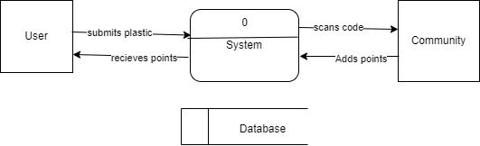

***Figure 3.1 Data Flow of the existing system***  (Urquijo, 2018),

### Advantages of the Existing System

The existing system, though simple, has several advantages that make it useful for promoting recycling within the community.

1. **Incentivized Recycling**: By offering users points for returning plastics, the system encourages greater participation in recycling efforts within the community.
2. **Streamlined Process**: The use of QR codes makes the process of tracking and rewarding users for their recycling straightforward and automated.
3. **Clear Accountabilit**y: Since QR codes are attached to individual products, the system can easily track the volume of plastics returned, providing clear data on recycling activity within the community.
4. **Encourages Environmental Awareness**: The system fosters a sense of environmental responsibility within the community by making recycling easy and rewarding.

### Disadvantages of the Existing System

Despite its strengths, the existing system has several drawbacks that limit its effectiveness and potential for growth.

1. **Limited to One Manufacturer**: The system is designed to handle only a single manufacturer, making it impossible to scale or involve multiple manufacturers, which restricts its impact on broader recycling efforts.
2. **Single Collection Point**: The system operates with only one collection point, which limits accessibility for users who may not be near the designated location. This could reduce the convenience and motivation for recycling among community members.
3. **No Flexibility for Other Materials**: The system is currently designed only for plastics, and there is no support for other recyclable materials such as glass or paper, which limits its overall effectiveness in promoting sustainable recycling practices.
4. **Lack of Advanced Feature**s: The existing system lacks advanced features, such as the ability to handle multiple collection centers or to offer more personalized rewards for different types of recyclables, reducing the overall engagement and growth potential.

These limitations, combined with the lack of scalability, highlight the need for a more flexible and adaptable solution that can accommodate multiple manufacturers, collection points, and materials.

## Analysis of the New System

The new system, Ecopint, introduces a more comprehensive and efficient approach to recycling by leveraging modern technology to streamline the collection, management, and rewarding of recyclable materials. Unlike the existing system, which is limited to a single manufacturer and one collection point, Ecopint is designed to support multiple manufacturers, products, and collection centers. This system allows manufacturers to retrieve their recyclable products, such as plastics, glass, and paper, from users through a digital platform.

Ecopint operates through two main interfaces: a web app for manufacturers and a mobile app for collectors. Manufacturers use the web app to register their products, assign points to encourage recycling, and generate unique QR codes for each product. These QR codes enable the tracking of each product's life-cycle from manufacturing to recycling. On the other hand, collectors such as malls, plazas, or shops act as intermediaries. The mobile app allows them to scan the QR codes on the recyclable products brought in by contributors, and points are then allocated to the contributor's account. The system is designed to automatically assign a small percentage of points to the collector as compensation for their role in the recycling process. Contributors register on the platform and can enter their bank details, enabling them to view and manage their points through the website. They accumulate points by returning recyclable products, and these points can be redeemed once a certain threshold is reached. This approach makes the system more flexible, scalable, and efficient, benefiting all parties involved which are the manufacturers.

### 3.2.1 Justification of the New System

The new system, Ecopint, is justified by the need for a more advanced, flexible, and scalable solution to address the limitations of the existing system. The traditional approach to recycling, while functional, lacks the ability to accommodate multiple manufacturers and collection points and recyclable products. Ecopint solves this issue by providing a platform that supports multiple manufacturers, products, and collection centers. This improves accessibility and convenience for users, enabling them to recycle from various locations and earn points for their contributions. Ecopint introduces a digital tracking system using QR codes, which ensures accurate and efficient monitoring of products from creation to recycling. By automating the process of point allocation and incorporating bank details for financial transactions, the system eliminates the manual errors and inefficiencies that plague the existing setup.

The introduction of a mobile app for collectors further enhances the system's flexibility, allowing any registered collection center to participate in the recycling process. This not only decentralizes recycling but also increases the reach and engagement of contributors. Ultimately, Ecopint is a scalable solution that promotes environmental sustainability while offering incentives to users and collectors, making it an innovative step forward in recycling practices.

## 3.3 Methodology Adopted

The development of the Ecopint system followed a structured methodology to ensure a robust, user-friendly, and scalable application. The Agile development methodology was adopted, allowing for iterative development, continuous feedback, and adaptive planning throughout the project life-cycle. This approach ensured that the system could be refined and improved based on user input and evolving requirements.

1. **Requirements Gathering**: The initial phase involved collecting detailed requirements from stakeholders, including manufacturers, collectors, and contributors. The goal was to understand the pain points of the current system and design a solution that addressed these issues while enhancing efficiency.
2. **System Design**: A modular architecture was designed, separating the web app for manufacturers and the mobile app for collectors, while both interfaced with a centralized backend system. This design ensured that each user group had a tailored experience, while the backend managed the critical functionalities of QR code generation, point allocation, and bank detail management.
3. **Development**: The development process was split into sprints, each focusing on a specific feature of the system. Technologies such as Node.js for the backend, HTML and BOOTSRAP for the frontend, and MongoDB for the database were employed to create a responsive and scalable platform.
4. **Testing**: After each sprint, the system will undergo vigorous testing, including unit testing, integration testing, and user acceptance testing. This ensured that both the web and mobile applications functioned seamlessly, and all edge cases were accounted for.

By adopting this methodology, Ecopint was developed as a reliable system that meets the needs of manufacturers, collectors, and contributors while promoting environmental sustainability.

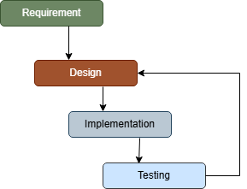

***Figure 3.2 System Methodology for the developed system***

## 3.4 High Model of the New System

The new system, Ecopint, follows a layered architecture that ensures scalability, flexibility, and ease of use. The system is designed to accommodate multiple actors (manufacturers, collectors, and contributors), with each actor interacting with specific parts of the system through tailored interfaces.

At the core of Ecopint is a centralized backend system that handles the creation of products, QR code generation, point allocation, and bank details management. This backend is responsible for managing the data flow between the different user interfaces: the web app for manufacturers and the mobile app for collectors.

The web app is primarily used by manufacturers. It allows them to register products, assign points for each recyclable product, and generate a QR code for tracking. The web app interacts with the backend to ensure that all product data, including points and QR codes, are stored securely in the system’s database.

The mobile app is designed for collectors, who act as intermediaries. Using the mobile app, collectors can scan the QR codes on the recyclable products brought by contributors, and the system automatically allocates points to the contributors’ accounts. The mobile app is integrated with the backend to ensure that point allocations are updated in real-time.

The contributors, or end users, interact with the system through the system’s website. After registering on the platform and entering their bank details, they can view their points by searching the website. The contributor’s account is linked to the points they earn, and they can monitor their progress towards redeeming these points.

In this high-level model, the database serves as the backbone, storing data related to users, products, points, and transactions. The system’s backend acts as the intermediary between all user interfaces, ensuring seamless communication and data integrity.

This modular architecture ensures that Ecopint can scale to support multiple manufacturers, collection points, and contributors while maintaining a smooth and efficient user experience.

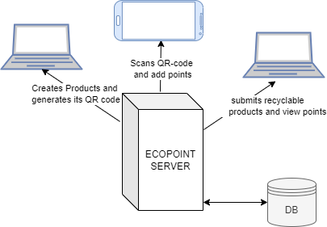

***Figure 3.3 Architectural Diagram of the developed system***

## 3.5 Specifications

### 3.5.1 Program Module Specification

The Ecopint system is divided into several modules, each responsible for handling specific tasks and functions. These modules include:

1. **User Module**: The User Module serves as the gateway for all users—manufacturers, collectors, and contributors—to interact with the Ecopint system. It manages the registration and authentication process, ensuring that each user is securely logged in. When users register, they provide essential information, including their role in the system, and set up their account with secure password management. The module also handles the management of bank details, which is crucial for facilitating transactions and rewards. By clearly defining user roles, the system can tailor the user experience and functionalities based on whether the user is a manufacturer, collector, or contributor.

***Algorithm***

* **Register User**

1. Collect user details (name, email, password, address, role).
2. Validate the input data.
3. Store the user information in the database.

* **Authenticate User:**

1. Collect login credentials (email, password).
2. Validate credentials against stored data.
3. Grant access if valid, deny access if invalid.

* **Manage Bank Details:**

1. Collect bank details (bank name, account number).
2. Validate the input data.
3. Update user profile with bank details.
4. **Product Module**: The Product Module is where manufacturers bring their recycling vision to life. It enables them to create new products in the system, assign a specific number of points as an incentive for recycling each product, and generate a unique QR code for tracking purposes. These QR codes serve as digital identifiers that link each product to the system's database, making it possible to track the recycling journey from collection to point allocation. Encouraging manufacturers to actively participate in the recycling process, this module ensures that every product has a clear path to being recycled.

***Algorithm***

1. Collect product details (name, category, points).
2. Generate a unique QR code.
3. Save product details to the database.
4. Allow QR code to be downloaded
5. **Point Module**: The Point Module is at the heart of Ecopint's incentive system. It automatically allocates points to contributors when collectors scan the QR codes on the recyclable products they bring in. This module ensures that contributors are rewarded for their efforts, with a percentage of the points also going to the collectors as a token of appreciation for their role in facilitating the recycling process. By making the allocation process automated and seamless, this module helps maintain user engagement and motivation, encouraging a continuous cycle of recycling

***Algorithm***

1. Enter Contributor's email
2. Collect QR code from the product.
3. Validate the QR code against the database.
4. Retrieve points assigned to the product.
5. Allocate points to the contributor.
6. Allocate a percentage of points to the collector.
7. Update the contributor's and collector's point balance in the database.
8. **Submission Module**: The Submission Module is crucial for providing transparency and insights into the recycling activities within the Ecopint system. It generates detailed reports for manufacturers, collectors, and contributors, offering a comprehensive view of the amount of material recycled and user activity. By compiling this data into easy-to-understand reports, the module helps stakeholders track progress and make informed decisions to improve the system.

***Algorithm***

1. Retrieve data on recycled materials, user activity, and point allocations.
2. Track system metrics (e.g., number of products recycled, Number of collectors, number of points awarded).
3. Present the report to manufacturers dashboard and history of contributors.

### 3.5.2 Database Development Tool

The Ecopint system uses MongoDB as its database management system. MongoDB was chosen for its flexibility, scalability, and compatibility with the system’s modular architecture. The NoSQL nature of MongoDB allows for dynamic schema definition, which is crucial for handling a variety of data types, including user profiles, product data, points allocation, and transaction history. The database is designed to ensure data integrity and security while providing the ability to handle unstructured data efficiently. MongoDB document-based structure allows for proper relationships between manufacturers, products, collectors, and contributors, making it highly adaptable to the system’s evolving needs.

### 3.5.3 Database Design and Structure

The database is organized into several tables, each serving a specific purpose:

1. Users Table: Stores user information, including roles (manufacturer, collector, or contributor), contact details, and bank information.
2. Products Table: Contains details about the products, including product names, associated points, and generated QR codes.
3. Points Table: Tracks the points allocated to contributors and the percentage allocated to collectors upon scanning a QR code.
4. Transactions Table: Keeps a record of point conversions and monetary transactions made through the system.
5. Submission Table: Keeps record of the user submission and points allocated

This structured approach to database design ensures that the system can easily manage and retrieve the data needed for real-time operations.

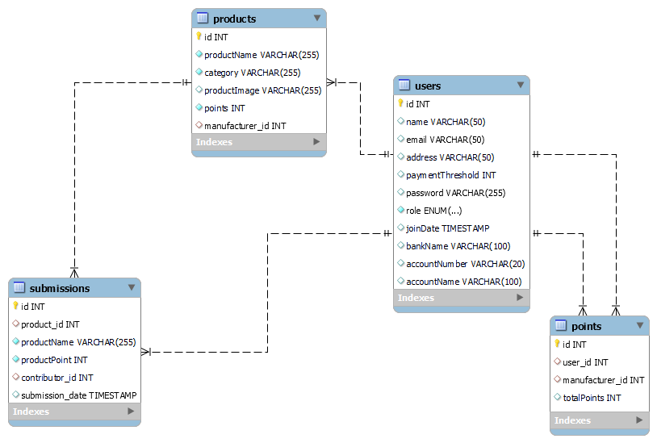

**Figure 3.4 Entity Relationship Diagram of the developed system**

### 3.5.4 Input/Output Design

**Input**: The system collects input from various users:

1. Manufacturers: Enter product details such as product name, type, points, and generate QR codes via the web app. All inputs are validated to ensure accuracy.
2. Collectors: Use the mobile app to scan QR codes and input contributors' email addresses to allocate points. They also enter their bank details, which are securely validated and stored.
3. Contributors: Register through the web app by providing personal information and bank details. The system validates these inputs for secure transactions.

Data validation at each stage ensures correct entries and smooth operations.

**Output**: The system delivers various outputs:

1. Contributors: Can view their accumulated points and recycling history, as well as transaction details related to point conversions.
2. Collectors: Receive reports showing products scanned, points allocated, and their earnings from recycling activities.
3. Manufacturers: Access detailed reports on recycled products, QR code usage, and point allocations, helping them track the impact of their recycling efforts.
4. This streamlined input/output process ensures all users receive relevant information while maintaining system efficiency and accuracy.

### 3.5.5 Data Dictionary

#### **Table 3.1 Points Model Data Dictionary**

|  |  |  |
| --- | --- | --- |
| **Field Name** | **Data Type** | **Description** |
| user | ObjectId | Reference to contributor (User) |
| manufacturer | ObjectId | Reference to manufacturer (User) |
| totalPoints | Number | Total points accumulated from this manufacturer |

**Table 3.2 Product Model Data Dictionary**

|  |  |  |
| --- | --- | --- |
| **Field Name** | **Data Type** | **Description** |
| productName | String | Name of the product |
| category | String | Category of the product |
| productImage | String | Image of the product |
| points | Number | Points assigned to the product |
| manufacturer | ObjectId | Reference to manufacturer (User) |

**Table 3.3 Submission Model Data Dictionary**

|  |  |  |
| --- | --- | --- |
| **Field Name** | **Data Type** | **Description** |
| product_id | ObjectId | Reference to product (Product) |
| productName | String | Name of the product submitted |
| productPoint | Number | Points for the submitted product |
| contributor_id | ObjectId | Reference to contributor (User) |
| submission_date | Date | Date of submission |

**Table 3.4 User Model Data Dictionary**

|  |  |  |
| --- | --- | --- |
| **Field Name** | **Data Type** | **Description** |
| name | String | Name of the user |
| email | String | Email of the user |
| address | String | Address of the user |
| password | String | Password of the user |
| role | String (Enum) | Role of user (manufacturer, collector, contributor) |
| joinDate | Date | Date the user joined |
| .bankName | String | Bank name of the user |
| accountNumber | String | Bank account number |
| accountName | String | Bank account name |

#### 3.5.6 Algorithm

The core algorithm of the Ecopint system involves point allocation, which is triggered when a collector scans a QR code. The algorithm calculates the points based on the product type, assigns them to the contributor, and allocates a percentage to the collector. The steps include:

1. Manufacturer registers product and assigns points to it, QR code is generated for product
2. Collector enters contributor’s email and scans the QR code for submitted product
3. The system identifies the product and retrieves its associated points and assigns it to the email input.
4. Points are added to the contributor’s account, and a percentage is allocated to the collector.
5. The system updates the database to reflect the new point totals for both the contributor and collector.

## 3.6 System Flowchart

The system flowchart illustrates the process from the creation of products by manufacturers to the scanning of QR codes by collectors and the allocation of points to contributors. This flow ensures that all interactions between users and the system are efficient.

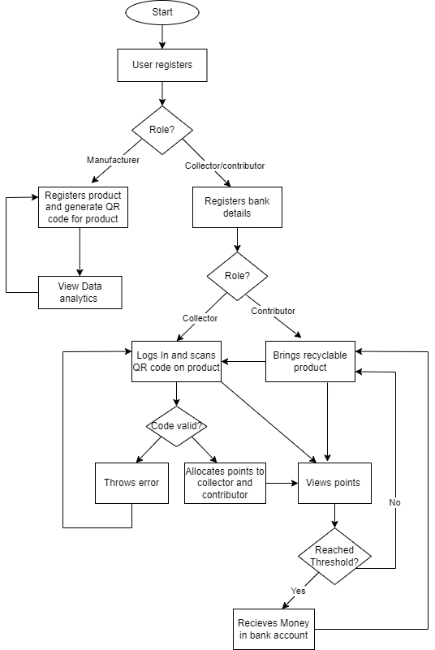

***Figure 3.5 System Flow chart***

# 

# CHAPTER FOUR: SYSTEM IMPLEMENTATION, TESTING, RESULTS AND DOCUMENTATION

## System Implementation

The implementation of the Ecopint system was carried out using a modular approach to ensure flexibility, scalability, and ease of integration between different components. The system consists of two main applications: a web app for manufacturers and a mobile app for collectors, both of which interact with a centralized backend that handles QR code generation, point allocation, and user data management.

The development process involved iterative phases of design, coding, testing, and deployment to guarantee that each component functioned as expected. The **Node.js** environment was used for the backend, providing an asynchronous, event-driven architecture ideal for handling the real-time operations of the system. The frontend interfaces were built using HTML and BOOTSTARP for the web application and **React Native** for the mobile app, ensuring a responsive and smooth user experience across devices.

Data management was centralized using **MongoDB**, a NoSQL database that allowed for dynamic schema definition, which was critical for handling a diverse range of products, QR codes, and user interactions.

### 4.1.1 New System Requirements

The implementation of the Ecopint system was carried out using a modular approach to ensure flexibility, scalability, and ease of integration between different components. The system consists of two main applications: a web app for manufacturers and a mobile app for collectors, both of which interact with a centralized backend that handles QR code generation, point allocation, and user data management.

The development process involved iterative phases of design, coding, testing, and deployment to guarantee that each component functioned as expected. The Node.js environment was used for the backend, providing an asynchronous, event-driven architecture ideal for handling the real-time operations of the system. The frontend interfaces were built using React.js for the web application and React Native for the mobile app, ensuring a responsive and smooth user experience across devices.

Data management was centralized using MongoDB, a NoSQL database that allowed for dynamic schema definition, which was critical for handling a diverse range of products, QR codes, and user interactions.

The Ecopint system required a careful balance of hardware and software components to ensure seamless functionality and high performance. The requirements were categorized into hardware and software to cater to both the development and operational stages.

1. **Hardware Requirements**

1. Server

2. Development Machine

* A laptop to access web application
* Mobile Devices for Testing:

**b. Software Requirements**

* Backend: Node.js: Version 18.x or higher, used for building the backend server and handling API requests, MongoDB: NoSQL database for storing user data, products, QR codes, and points, Express.js: Web framework for building RESTful APIs and managing server-side logic
* Frontend (Web Application): React.js: A JavaScript library for building the manufacturer web interface, Bootstrap: For responsive design and ensuring cross-browser compatibility, Axios: For handling API requests from the frontend to the backend server, Instasacn for enabling the Camera scan Images.
* Frontend (Mobile Application):React Native: For developing the cross-platform mobile application used by collectors
* Version Control: Git: For source code management and version control and GitHub for collaborative development and storing code repositories
* VS Code: As the development environment for coding and debugging

These hardware and software requirements ensured that the Ecopint system was able to operate efficiently, handle user interactions smoothly, and provide a robust platform for recycling management.

## 4.1.2 Program Development

The program development for Ecopint followed a structured approach using modern programming environments and languages that aligned with the system's performance and scalability needs.

**a. Choice of Programming Environment**

1. Node.js Environment: Node.js was selected as the primary environment for backend development due to its non-blocking, event-driven architecture. This choice allowed for high performance and scalability, particularly important for real-time operations such as QR code generation and point allocation. The asynchronous nature of Node.js made it ideal for handling multiple user requests simultaneously.
2. React.js and React Native: React.js was chosen for the web application due to its ability to build highly dynamic and interactive user interfaces. React’s component-based architecture facilitated modular development, allowing for easier maintenance and scalability. Similarly, React Native was used for developing the mobile application, providing a seamless cross-platform experience for both Android and iOS devices. Expo CLI was integrated to streamline mobile app development, testing, and deployment.
3. MongoDB: MongoDB was chosen as the database because of its flexibility in managing unstructured data, which was essential for storing varied product and user information. The document-based structure of MongoDB made it easy to manage complex relationships between users, products, and QR codes.
4. **Language Justification**

JavaScript was the language of choice for both frontend and backend development. Using JavaScript across the entire technology stack offered several advantages:

* Consistency: Developers could write both server-side and client-side code in the same language, improving collaboration and reducing context switching.
* Rich Ecosystem: JavaScript has a vast ecosystem of libraries and tools, such as Express.js for backend development and Axios for handling API requests. This provided flexibility in building a wide range of features quickly and efficiently.
* Cross-platform Development: With React Native, JavaScript enabled the development of cross-platform mobile apps, ensuring that the collector’s mobile app worked on both Android and iOS without needing separate code-bases for each.

MongoDB was selected due to its flexibility in handling unstructured and semi-structured data. Since the system required dynamic schema changes to accommodate different products, users, and their recycling activities, MongoDB’s document-oriented approach was ideal. Additionally, its horizontal scalability ensured the system could grow as more users, products, and recycling centers were added. By leveraging these programming environments and languages, the Ecopint system was able to achieve its goals of flexibility, scalability, and efficient performance, all while maintaining a seamless user experience for manufacturers, collectors, and contributors.

## Testing and Results

Testing is a critical phase in the system development lifecycle, ensuring that all functionalities of the Ecopint system perform as expected. The testing process involved multiple phases, including unit testing, integration testing, and user acceptance testing, to ensure that each module functioned properly both individually and when integrated with others. The primary goal was to verify the system's stability, accuracy, and performance under different scenarios and usage loads.

### System Testing

**a. Test Plan**

The test plan was designed to evaluate the system's functionality across all major components, including the web app for manufacturers, the mobile app for collectors, and the backend system. Each component was tested individually, followed by integration testing to ensure seamless communication between the frontend and backend. The following tests were included in the plan:

1. Unit Testing: Each module (e.g., product creation, QR code generation, point allocation) was tested in isolation to ensure that it performed as expected. For instance, manufacturers’ ability to register products and generate QR codes was tested for accuracy and completeness.
2. Integration Testing: The interactions between different components (web app, mobile app, backend) were tested to ensure that data flowed correctly. For example, when a collector scanned a QR code, the system was tested to verify that points were correctly allocated to the contributor's account and reflected in the backend.
3. User Acceptance Testing (UAT): Real users, including representatives from manufacturers, collectors, and contributors, were involved in testing the system's usability and performance. Feedback from users helped refine certain features, such as the mobile app’s scanning speed and the web app’s user interface.
4. Performance Testing: The system was tested under heavy load to ensure it could handle a large number of simultaneous users and transactions without lag or crashes. Stress tests were performed to evaluate the system’s behavior when a large number of QR codes were scanned and points were allocated within a short time frame.

**b. Test Data**

Test data was created to simulate real-world usage scenarios and verify that the system handled various inputs correctly. The following test data sets were used:

1. User Data: Manufacturer accounts with details such as name, email, and registered products, collector accounts with valid email addresses and mobile devices to scan QR codes and contributor accounts, including personal information and bank details, were entered to test registration, point allocation, and point redemption.
2. Product Data: Products were created with various point values, categories (plastics, glass, paper), and QR codes. Different combinations of product types and point values were used to verify that the system allocated the correct points when scanned by collectors.
3. QR Code Scanning: Multiple QR codes were generated and tested to verify that the system recognized each code and allocated the correct points to contributors. Invalid or duplicate QR codes were used to test the system’s error handling capabilities.
4. Points Allocation: Points were tested by simulating different scenarios in which collectors scanned QR codes under various conditions (valid codes, expired codes, duplicate scans). The system’s ability to allocate points correctly to both contributors and collectors was validated.
5. Bank Details and Transactions: Bank details were entered for both contributors and collectors to test the system’s ability to store, encrypt, and process transactions securely. Test data included valid and invalid bank details to ensure that the system handled errors appropriately

By using this comprehensive test plan and test data, the Ecopint system was thoroughly evaluated to ensure functionality, accuracy, and security. Each test case provided valuable insights into areas where the system could be optimized, and the results of the tests guided further refinement of the platform.. **Performance evaluation was a crucial part of the Ecopint system testing process to ensure that the platform could handle real-world usage under varying conditions. The following metrics were used to evaluate the system’s performance:**

1. **Response Time: The time it took for the system to respond to requests was monitored, particularly for critical operations such as product registration, QR code generation, point allocation, and user authentication. The system consistently performed within acceptable limits, with an average response time of less than 1 second for most operations.**
2. **Scalability: The system was stress-tested with a large number of concurrent users and transactions to evaluate its scalability. The MongoDB database and Node.js backend were able to scale effectively under heavy load.**
3. **QR Code Processing: The time taken for QR codes to be scanned and processed was measured. On average, the system could process QR codes in less than 0.5 seconds, ensuring a smooth experience for collectors and contributors.**

**Overall, the system demonstrated robust performance under various scenarios, with minimal downtime and quick response times, even when handling a large number of users and transactions.**

****c. Limitations of the System****

**Despite the Ecopint system's overall success in terms of functionality and performance, there are several limitations that should be addressed in future iterations:**

1. **Geographic Limitations for Collectors: The system depends on registered collectors at designated collection points, and it currently lacks the ability to integrate with third-party recycling services or provide broader geographic coverage. Expanding the system to include more flexible collection methods or partnerships with external recycling centers would enhance its reach.**
2. **Manual QR Code Scanning: While the system allows collectors to scan QR codes for product recycling, the process is manual and dependent on the collector’s availability. Automating certain aspects of the QR code scanning process, such as integrating IoT-enabled recycling bins, could reduce the need for human intervention and make the process more efficient.**
3. **Dependency on Internet Access: The system requires stable internet access for real-time transactions between the web app, mobile app, and backend. In regions with unreliable or limited internet connectivity, users and collectors may face difficulties in accessing the system.**
4. **Point Redemption: While the system allows contributors to accumulate points for recycling, the options for redeeming these points are currently limited to direct monetary conversion. Future enhancements could include additional options, such as redeeming points for vouchers, discounts, or donations to environmental causes, which could increase user engagement.**

## 4.3 Results and Documentation

**The Ecopint system’s interface**

This is designed to be user-friendly, ensuring seamless interactions between manufacturers, collectors, and contributors. The interface is divided into two main parts: the Web Application for manufacturers and the Mobile Application for collectors. Below are the key screens and work-flows that users interact with, along with suggested images that can be included for better understanding.

### 4.3.1 Web Application for Manufacturers

**The system’s Home Page**

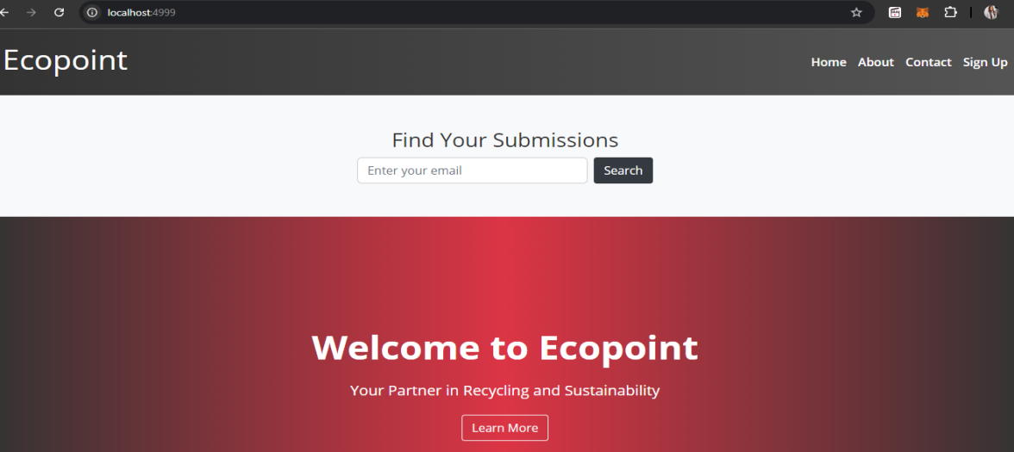

***Figure 4.0 Home Page***

**1. Manufacturer Dashboard:** The main interface where manufacturers can view their registered products, track product recycling statistics, and generate new QR codes.

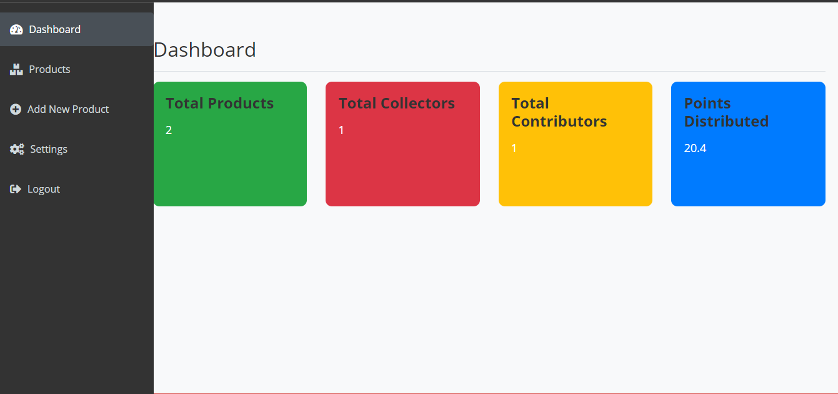

***Figure 4.1 Manufacturer Dashboard***

**2. Product Registration Page:** This page allows manufacturers to add new recyclable products, including product name, category, points, and upload images.

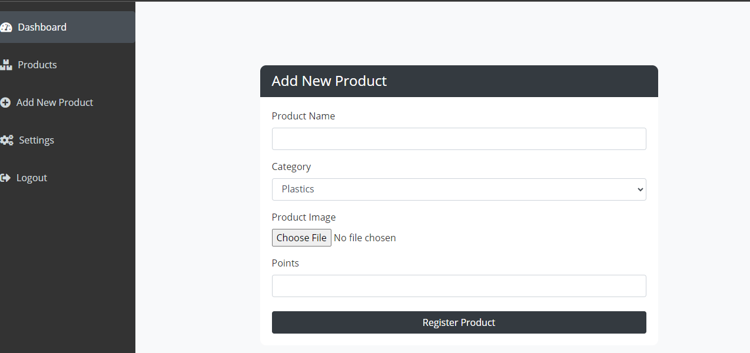

***Figure 4.2 Manufacturer Add product***

**3. Product page*:*** After registering a product, the manufacturer can manage their product by viewing, updating or deleting.

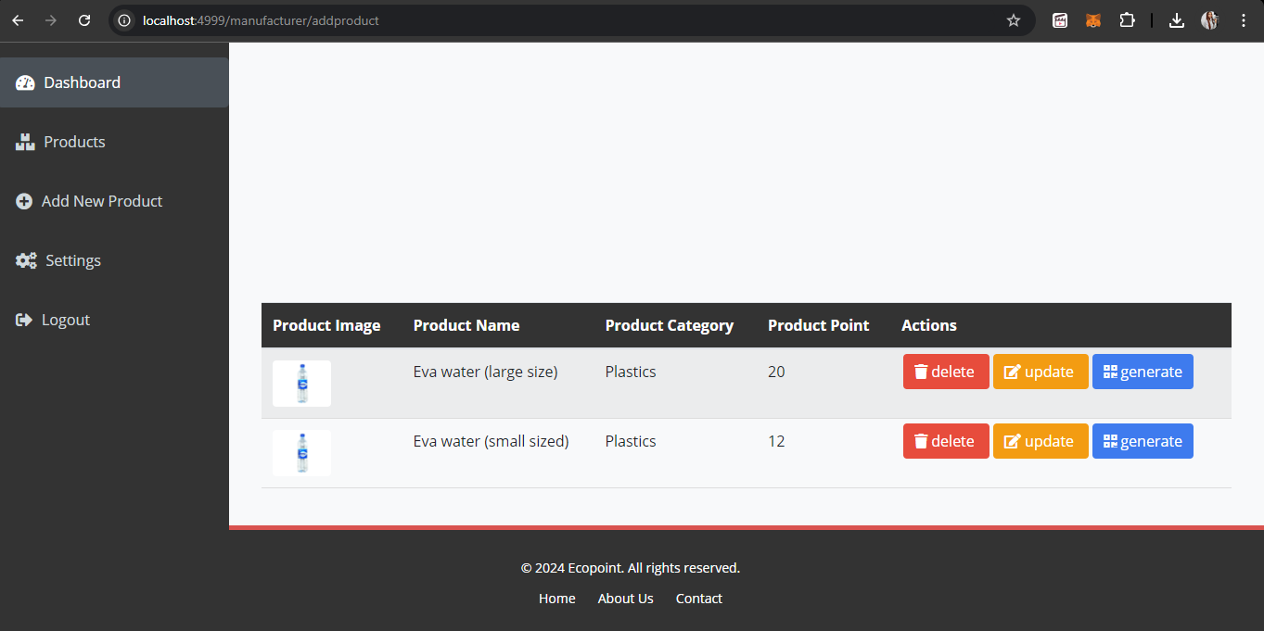

***Figure 4.3 Manufacturer Product management***

**3. QR Code Generation Page**: After registering a product, the system generates a unique QR code that manufacturers can download and place on their products.

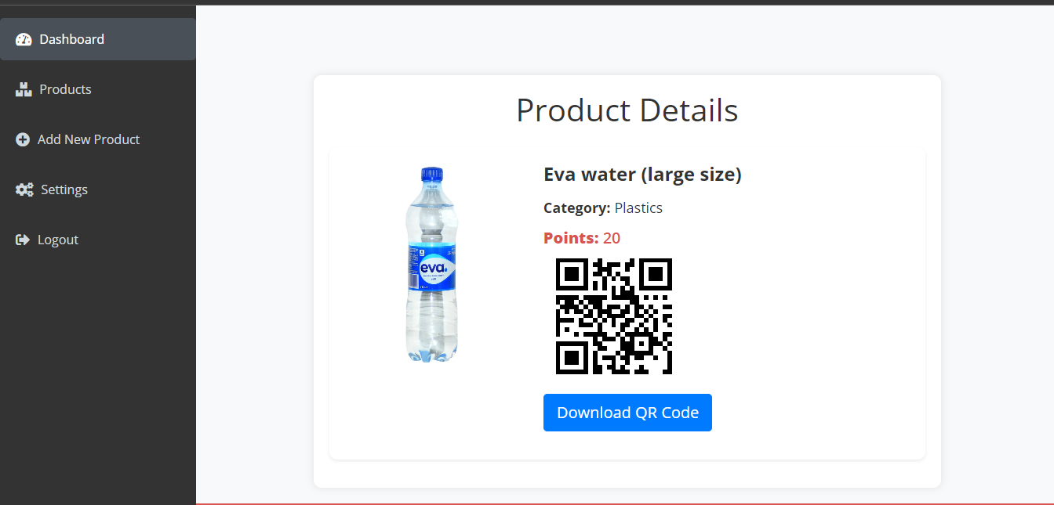

***Figure 4.4 QR-code generation***

#### The settings: Manufacturers can set Threshold points for contributors and collectors such that when that point is reached money can be transferred to their registered accounts.

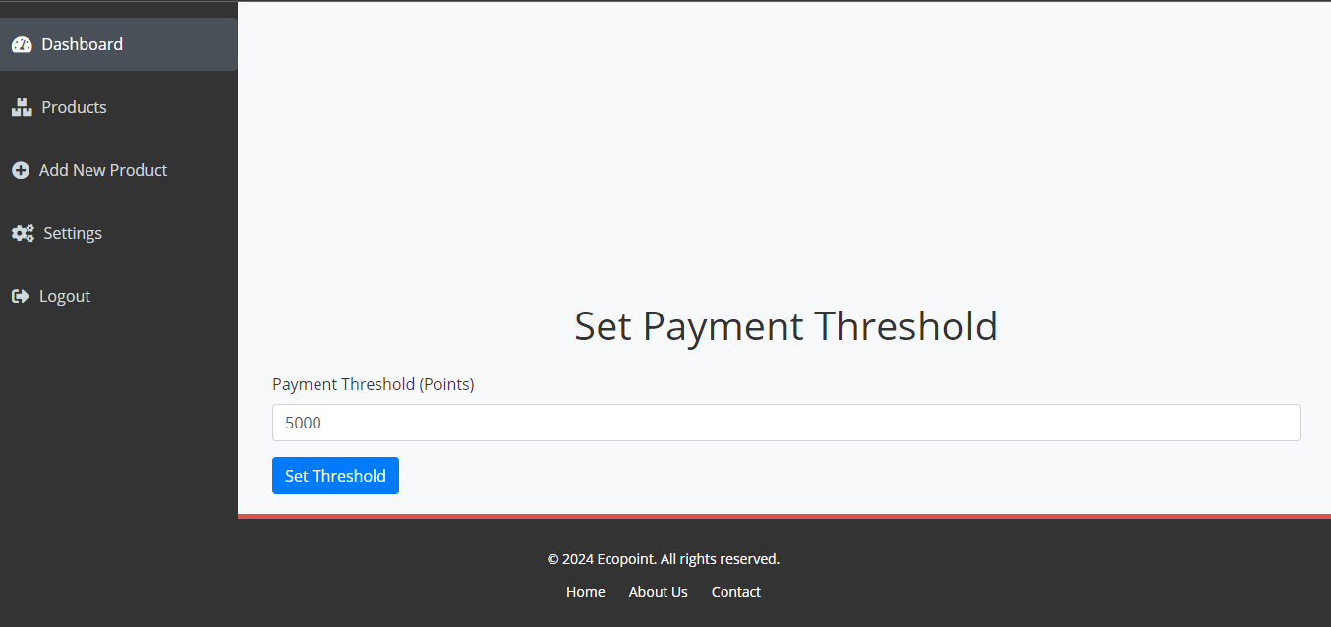

***Figure 4.5 Payment Threshold settings***

### 4.3.2 Mobile Application for Collectors

**1. Collector Dashboard**: The main interface where collectors can points gotten.

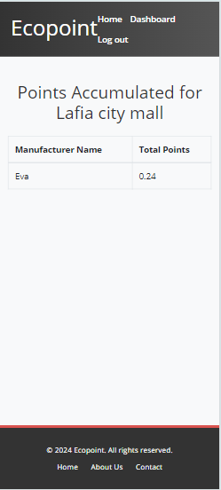

***Figure 4.6 collector points***

**2. QR Code Scanning Interface:** Collectors use this interface to scan the QR codes on products brought in by contributors. The system instantly allocates points to the contributor.

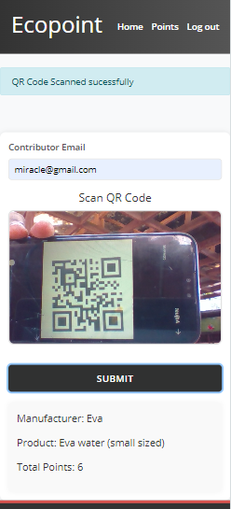

***Figure 4.7 Collector Scanning Interface***

**3. Point Allocation Summar**y: After scanning a QR code, the app shows a summary of the points allocated to the contributor and the percentage earned by the collector.

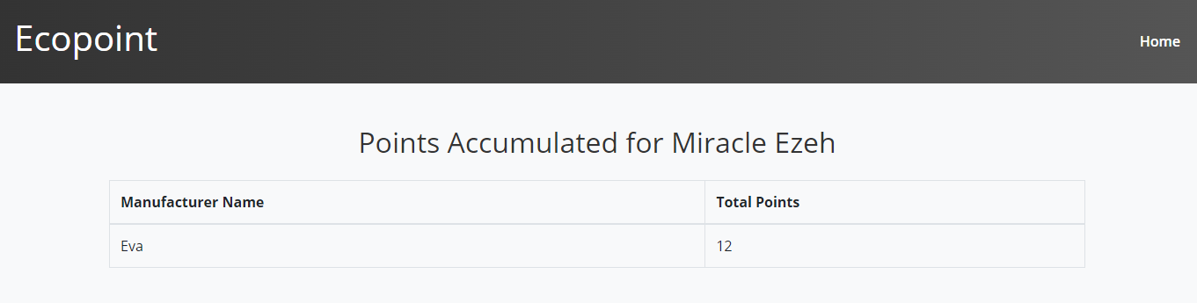***Figure 4.8 contributor points***

### 4.3.3 All user’s interface

**1. Registration Page**: Users can register and enter their personal and bank details on this page to start tracking their recycling contributions.

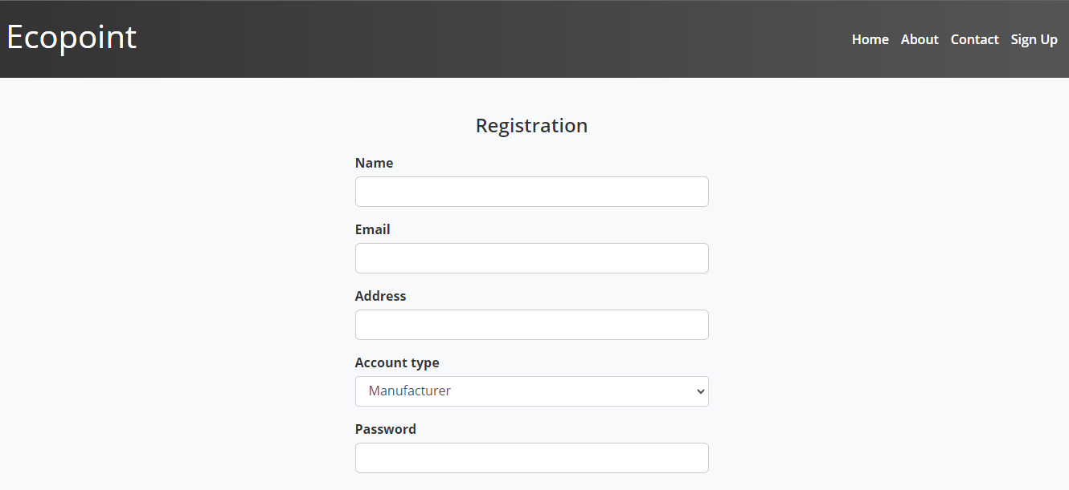

***Figure 4.9.1 Registration Page***



***Figure 4.9.2 Login Page***



***Figure 4.9.3 Bank details Page***

1. **Website**: Once registered, contributors can view their accumulated points by making a search

on Ecopoint’s website without logging in.



***Figure 4.9.4 Query for contributor points***

### 4.3.3 Error Handling

The Ecopint system incorporates robust error-handling mechanisms to ensure smooth and reliable operations. For users not registered or duplicate email registration displaying relevant error messages if issues arise. During user registration and bank detail submission, input validation ensures that only correct information is accepted. In cases of network connectivity issues, the system notifies users and attempts to resubmit requests once connections are restored. Errors related to authentication, point allocation, and server or database issues are also managed effectively, providing clear feedback to users and ensuring data integrity and security throughout the system.



***Figure 4.10 Handling error***

# 

# CHAPTER FIVE: SUMMARY, CONCLUSION AND RECOMMENDATION

## 5.1 Summary

The development of the Ecopint system marked a significant step forward in modernizing the recycling process by incorporating technology to streamline operations and incentivize participation. At its core, Ecopint was designed to address the gap in traditional recycling systems, which often lack effective ways to engage users, track recycling activities, or reward participants. By introducing a structured, technology-driven platform, Ecopint effectively engages three primary user groups—manufacturers, collectors, and contributors—and fosters a collaborative recycling effort.

The system functions through the use of a web-based application for manufacturers and a mobile application for collectors, both of which are connected through a centralized backend system. Manufacturers play a key role in registering recyclable products, assigning reward points, and generating QR codes that allow the products to be tracked throughout their life-cycle. Contributors, on the other hand, serve as the primary recyclers, bringing products to collection points where collectors scan the QR codes to allocate points.

The system ensures transparency and fairness by automatically distributing points based on the type and quantity of materials recycled, offering contributors the opportunity to accumulate rewards, which they can later redeem. Collectors also benefit from the system by receiving a percentage of the points for each item they process, creating a shared incentive across the recycling chain.

Throughout the system development, various technologies were employed to ensure smooth operations and scalability. The backend system was built using Node.js and Express, providing an efficient server-side environment for handling API requests and managing data. MongoDB served as the database of choice, offering flexibility in storing data related to products, users, and transactions. The frontend interfaces, powered by React for the web app and React Native for the mobile app, allowed for a responsive and user-friendly experience.

Testing was an essential part of the development process. The system underwent rigorous testing phases, including unit testing, integration testing, performance testing, and user acceptance testing (UAT). The results demonstrated that Ecopint could handle a significant number of transactions, ensuring real-time point allocation, reliable QR code scanning, and quick responses from both the web and mobile applications. Despite some limitations, such as geographic constraints, limited material types, and reliance on stable internet access, Ecopint proved to be a robust solution that effectively met the project’s goals.

In summary, the Ecopint system successfully combines technology with environmental sustainability by making the recycling process more transparent, engaging, and rewarding. By addressing key gaps in traditional systems, Ecopint provides a scalable and efficient platform for manufacturers, collectors, and contributors, ultimately promoting a more circular economy and encouraging greater environmental responsibility.

## 5.2 Conclusion

The Ecopint system represents a forward-thinking approach to recycling, designed to modernize and incentivize the process for manufacturers, collectors, and contributors. In traditional recycling methods, there has often been a lack of engagement and accountability, leading to lower participation rates and inefficiencies in recycling operations. Ecopint tackles these challenges by providing a digital platform where each participant in the recycling chain can clearly track their contributions, earn rewards, and benefit from a more organized, transparent process.

One of the key achievements of Ecopint is its seamless integration of multiple user types through a single, centralized platform. The system effectively bridges the gap between manufacturers, who register products and set reward points, and contributors, who actively participate in recycling efforts by returning products with attached QR codes. The collectors, who act as intermediaries, play an important role in scanning these QR codes, ensuring that points are correctly allocated in real-time.

From a technical perspective, Ecopint harnesses modern technologies to create a scalable and reliable system. The decision to use Node.js for the backend ensures that the system can handle large volumes of transactions, while MongoDB provides the flexibility needed to manage diverse data sets. The use of React.js and React Native for the web and mobile applications respectively ensured that the user interfaces were responsive and intuitive, catering to a broad range of users, regardless of their technical expertise. The system's modular architecture also allows for future expansions, such as integrating additional recyclable materials, expanding geographically, or partnering with third-party recycling initiatives.

Despite the success of the system, some limitations were identified during the development and testing phases. For instance, the system is currently limited to handling specific recyclable materials, and there is a reliance on stable internet access to process transactions in real-time. We can say the system’s user interfaces are currently only available in English, which may limit its accessibility to non-English-speaking regions. Addressing these limitations in future iterations will be key to ensuring that Ecopint can scale to meet the needs of a global user base.

In conclusion, Ecopint provides a meaningful solution to the ongoing challenges of recycling, offering a platform that not only simplifies the recycling process but also makes it more rewarding and engaging for all participants. By creating a system that tracks products from manufacturing to recycling and incentivizes users at each step of the process, Ecopint promotes a more circular economy and encourages individuals and organizations alike to contribute to a more sustainable future. As the system continues to evolve, there is significant potential for further growth, both in terms of expanding its functionality and increasing its reach to new regions and users.

## 5.3 Recommendation

Based on the development and performance of the Ecopint system, it is clear that technology can play a transformation role in revolutionizing the recycling process. However, several recommendations arise from both the system's strengths and its limitations, which could guide future improvements and adaptations of the platform.

First, expanding the range of recyclable materials handled by Ecopint is essential. Currently, the system is designed for common materials such as plastics, glass, and paper, but there is a significant opportunity to broaden its impact by integrating other materials like metals, textiles, and e-waste. This would not only increase the system’s reach but also make it more attractive to contributors who regularly handle a wider variety of recyclable goods.

Second, there is a strong case for enhancing user accessibility and engagement by offering additional redemption options beyond just monetary rewards. Contributors could be offered alternative incentives, such as vouchers, discounts from partnered stores, or donations to environmental causes. This would appeal to a broader user base and encourage more consistent engagement with the system, as it diversifies the rewards contributors can choose from based on their preferences.

Another key recommendation involves automating certain aspects of the system. Currently, the QR code scanning process relies heavily on human interaction, particularly from collectors. Introducing automation, such as IoT-enabled recycling bins that can scan QR codes and allocate points automatically, would reduce the need for human involvement and improve efficiency. This would also make the system more scalable, as automated bins could be placed in multiple locations without requiring the presence of a collector.

Lastly, addressing the geographical limitations of the system is crucial for its long-term scalability. Since Ecopint currently relies on physical collection points, expanding these locations or allowing more flexible collection methods will be necessary to grow the user base. Partnering with more third-party collection services or offering users the ability to mail in recyclable materials could further extend the platform’s reach.

### 5.3.1 Application Areas

The Ecopint system can be applied across a variety of sectors and environments, where the need for efficient and incentivized recycling is paramount. Some key areas where the system can be implemented include:

1. Educational Institutions: Schools, colleges, and universities can adopt Ecopint to encourage students and staff to participate in recycling efforts. The system can serve as an educational tool, teaching students about sustainability while rewarding them for their contributions. It could also be integrated into environmental awareness campaigns on campuses.
2. Retail and Commercial Spaces: Malls, supermarkets, and shopping centers can incorporate Ecopint by establishing collection points where customers can return recyclable materials. These establishments can partner with manufacturers and collectors to streamline the recycling process and use it as a green marketing initiative, offering points that can be redeemed for discounts on purchases.
3. Municipal Waste Management Programs: Local governments and municipalities can leverage Ecopint to improve their recycling infrastructure. By incentivizing residents to recycle, municipalities can reduce landfill waste and promote a more circular economy. Ecopint can serve as a tool for waste management departments to track and reward citizens for their recycling contributions.
4. Corporate Social Responsibility (CSR) Programs: Businesses that want to enhance their sustainability efforts can implement Ecopint as part of their CSR initiatives. By providing employees or customers with the opportunity to recycle and earn points, companies can demonstrate their commitment to environmental sustainability and corporate responsibility.
5. Events and Festivals: Large-scale events and festivals that typically generate significant waste can utilize Ecopint to manage recyclable materials. Event organizers can set up collection points for attendees to recycle materials like plastic cups, bottles, and packaging, while incentivizing them with rewards that can be used at the event or afterward.

### 5.3.2 Suggestions for Further Research

While the Ecopint system has demonstrated significant potential in promoting recycling through technology, there are several areas where further research could expand the system's capabilities and refine its impact:

1. Exploration of Additional Reward Mechanisms: Research into alternative reward mechanisms beyond points-to-cash conversions could provide new insights into how to enhance user engagement. Studies could explore how non-monetary rewards, such as discounts, vouchers, or social recognition, influence recycling behavior. This research could help diversify the system's reward offerings and make the platform more appealing to different user demographics.

2. Automation and Integration of IoT in Recycling: The integration of IoT technology, such as smart recycling bins that can automatically scan QR codes and allocate points without human intervention, presents an exciting avenue for research. Investigating how automated systems can reduce costs, increase efficiency, and scale the system to more locations could significantly enhance the system’s performance and reach.

3. Behavioral Analysis of Recycling Patterns: Understanding the behavioral patterns of contributor show often they recycle, what materials they recycle most, and what motivates them could lead to more personalized and effective incentives. Further research in this area could help refine how points are allocated and how users are encouraged to recycle consistently over time.

4. Scalability in Low-Internet Regions: Since Ecopint relies on internet connectivity, researching how to adapt the system for regions with low or unreliable internet access would be crucial for expanding its global reach. Future research could focus on hybrid models that allow offline functionality with periodic synchronization when connectivity is available.

By exploring these areas in more detail, Ecopint could evolve into an even more powerful tool for promoting recycling, making it more efficient, scalable, and adaptable to different user needs and environments.

# 

# REFERENCES

Bollweg, L., Lackes, R., Siepermann, M., & Frank, M. (2020). Digitalization of the circular economy – Opportunities and challenges for the recycling industry. Journal of Cleaner Production, 123456, 345-357. https://doi.org/10.1016/j.jclepro.2019.10.027

Cabalova, I., Kacik, F., Geffert, A., & Kacikov, D. (2011). The effects of paper recycling and its environmental impact. In InTech. https://doi.org/10.5772/23110

Forge Recycling. (2022, February 24). How paper recycling benefits the environment. Forge Recycling. https://www.forgerecycling.co.uk/blog/how-paper-recycling-benefits-environment/

Geyer, R., Jambeck, J., & Law, K. L. (2017). Production, use, and fate of all plastics ever made. Science Advances, 3(7), e1700782. https://doi.org/10.1126/sciadv.1700782

Gibovic, D., & Bikfalvi, A. (2021). Incentives for plastic recycling: How to engage citizens in active collection. Empirical evidence from Spain. Recycling, 6(2), 29. https://doi.org/10.3390/recycling6020029

Hsu, C. L., & Chen, M. C. (2021). Advocating recycling and encouraging environmentally friendly habits through gamification: An empirical investigation. Technology in Society, 66, 101621. https://doi.org/10.1016/j.techsoc.2021.101621

Hughes, M. (2022, February 24). How paper recycling benefits the environment. Forge Recycling. https://www.forgerecycling.co.uk/blog/how-paper-recycling-benefits-environment/

Kalantarifard, A., & Yang, G. S. (2012). Identification of the municipal solid waste characteristics and potential of plastic recovery at Batu Pahat Landfill, Malaysia. Journal of Sustainable Development, 5(7), 11-17.

Kim, J., & Shin, N. (2017). The use of QR code in mobile marketing. Journal of Marketing & Public Policy, 36(4), 404-416.

Koskinopoulou, M., Raptopoulos, F., Papadopoulos, G., Mavrakis, N., & Maniadakis, M. (2021). Robotic waste sorting technology: Toward a vision-based categorization system for the industrial robotic separation of recyclable waste. IEEE Robotics & Automation Magazine, 28(2), 50-60. https://doi.org/10.1109/MRA.2021.3066040

Krasny, M. E. (2020). Advancing environmental education practice. Cornell University Press.

Mohammed, M. A., Abdulhasan, M. J., Kumar, N. M., et al. (2023). Automated waste-sorting and recycling classification using artificial neural network and features fusion: A digital-enabled circular economy vision for smart cities. Multimedia Tools and Applications, 82(39617), 39617–39632. https://doi.org/10.1007/s11042-021-11537-0

Renard, L. (2020, May 18). Using reward systems to motivate students. BookWidget Teachers Blog. https://www.bookwidgets.com/blog/2020/05/using-reward-systems-to-motivate-students

Tan, M., Zhang, Y., & Chen, X. (2018). QR codes in supply chain management: Improving transparency and reducing errors. International Journal of Supply Chain Management, 7(2), 121-130.

Urquijo, J. (2018, March 3). Throwing garbage away properly has a reward with WasteApp. Green Apps and Web. https://www.greenappsandweb.com/en/android-en/inorganic-organic-waste-wasteapp/

Yuan, S., Zheng, Y., & Zhang, M. (2016). The evolution and application of QR code technology. Journal of Technology Innovation, 19(2), 102-115.

Zhang, S., Zhang, M., Yu, X., & Na, H. (2020). Smartphone-based solutions for municipal solid waste management in a smart city context: A systematic review and future agenda. Resources, Conservation and Recycling, 161, 104947. https://doi.org/10.1016/j.resconrec.2020.104947

Zhang, Y., Tan, M., & Liu, W. (2020). Leveraging real-time data in sustainable waste management. Sustainable Cities and Society, 60, 102-115.

# APPENDIX: SOURCE CODE

1. **The QR code generator handler**

const generateQrCode = async (req, res) => {

    const user = await User.findOne({ email: req.user.email });

    const productId = req.params.id

    const product = await Product.findOne({ _id: productId }).select('productName category points productImage')

    const qrCode = 'https://api.qrserver.com/v1/create-qr-code/?size=150x150&data=' + productId;

    res.render('manufacturer/viewProduct', {

        user,

        product,

        qrCode,

        token: req.user.token,

        message: "",

        error: ""

    });

}

1. **The QR code scanner**

const scanProduct = async () => {

    try {

        // Initialize the QR code scanner

        let scanner = new Instascan.Scanner({ video: document.getElementById('preview') });

        // Event listener for scan event

        scanner.addListener('scan', (content) => {

            document.getElementById('productQrCode').value = content;  // Set the scanned QR code to hidden input

            // Display the scanned message on the screen

            const scanMessage = document.getElementById('scan-message');

            scanMessage.textContent = "QR Code Scanned successfully!";

            scanMessage.style.display = 'block';  // Make the message visible

        });

        // Fetch available cameras

        const cameras = await Instascan.Camera.getCameras();

        if (cameras.length > 0) {

            // Use the rear camera on mobile devices if available

            const rearCamera = cameras.find(camera => camera.name.toLowerCase().includes('back')) || cameras[0];

            scanner.start(rearCamera);  // Start scanning with the rear camera if available, otherwise use the first camera

        } else {

            console.error('No cameras found.');

            const scanMessage = document.getElementById('scan-message');

            scanMessage.textContent = 'No cameras found. Please ensure camera permissions are granted.';

            scanMessage.style.display = 'block';  // Display error message

        }

    } catch (error) {

        console.error('Error initializing scanner:', error);

        const scanMessage = document.getElementById('scan-message');

        scanMessage.textContent = 'An error occurred while initializing the QR code scanner.';

        scanMessage.style.display = 'block';  // Display error message

    }

};

1. **The server (app.js)**

require('dotenv').config()

const express = require('express')

const connectDB = require('./DB/config')

const DB_URI = process.env.MONGO_URI

const cookieParser = require('cookie-parser');

const authenticate = require('./middlewares/auth')

const errorHandler = require('./middlewares/errorHandler')

//Routes

const manufacturerRoute = require('./routes/manufacturerRoute')

const authRoutes = require('./routes/authRoute')

const contributorRoute = require('./routes/contributorRoute')

const collectorRoute = require('./routes/collectorRoute')

const app = express()

app.use(express.json());

app.use(cookieParser());

app.use(express.urlencoded({ extended: true }));

app.set('view engine', 'ejs')

app.set('views', './views');

app.use(express.static('static'));

app.use(authRoutes)

app.use('/manufacturer', authenticate, manufacturerRoute)

app.use('/contributor', contributorRoute)

app.use('/collector', authenticate, collectorRoute)

app.use(errorHandler)

const port = 4999 || process.env.PORT

const start = async () => {

    try{

        await connectDB(DB_URI)

        app.listen(port, console.log(`Server is running on port ${port}...`));

    } catch (error){

        console.log(error);

    }

}

start()

**The rest of the code can be found at https://github.com/Amazingmercy/Ecopoint**